Form of Call-Off Order – (Clause 1, Section 2)
Call Off NUMBER: 2022-005 | CALL-OFF ORDER
This Call-Off Order is issued on the date of execution by TAQA, pursuant to the Call-Off Contract for the Supply of Goods and Performance of Services between:
TAQA ATRUSH B.V., a private limited company organised and existing under the laws of the Netherlands and having its branch registered in Erbil, Kurdistan Region, Republic of Iraq under registration number 16664, and located at: Empire Business Complex, Ground and First Floor, Building C1, Erbil, Kurdistan Region of Iraq (“TAQA”); and
[Starlight] (the “Contractor”),
with Contract Reference Number: [TAQA-2022-0027 (the “Contract”).
Except where defined in this Call-Off Order, capitalised words and expressions used herein shall have the meanings ascribed to them in the Contract.
PART 1: WORK INSTRUCTED UNDER THIS CALL-OFF ORDER
The Contractor shall collect or receive the Consigned Property at the Collection Point on the Collection Date and the Contractor shall transport and deliver the Consigned Property to the Delivery Point on the Delivery Date.
The Schedule to this Call-Off Order specifies:
- the Consigned Property,
- the Collection Point;
- the Delivery Point;
- the Packing List & Commercial Invoice;
- the Gross Weight
- the CHW Weight/ BOL Weight;
- the Airline/ Shipping Line
- the Collection Date
- the Method of Transport;
- the Estimation Time of Arrival;
- the Declared Value of the Consigned Property.
PART 3: OTHER DETAILS RELATED TO THE WORK
PART 2: CALL-OFF PRICE
$580
PART 3: IMPORT CUSTOMS AND CLEARANCE
to be couriered
PART 4: GENERAL AND SIGNATURE
Except as supplemented by the terms of this Call-Off Order, all terms and conditions of the Contract shall remain in full force and effect per the contract.
Issued by TAQA by: |  | Acknowledged* by the Contractor:
…………………………………………..  (Signature) |  | 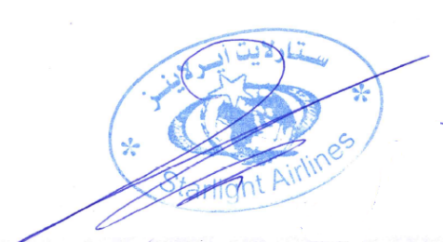  (Signature)
…………………………………………..  (Name in block capitals) |  | ALA AKRAM ………………………………..  (Name in block capitals)
…………………………………………..  (Position in company) |  | SENIOR PROJECT MANAGEMNET …………………  (Position in company)
…………………………………………..  (Date) |  | …………………………………………..  (Date)
*Provided that this Call-Off Order has been issued in accordance with the Contract, acknowledgement by the Contractor is not essential.

SCHEDULE

Call-Off NUMBER: 2022-005
Consigned Property - Item Ref | Consigned PO | Collection Point | Delivery Point | PL & CI NO | Gross Weight | CHW / BOL Weight | Airline/ Shipping Line | Collection Date | Method of Transport | ETA | Declared Value (US$)
S2-T-1 | 25153 | USA | Erbil | 12841385 | 5 kg | 8 kg | TK | 2-Nov-2022 | Air | 7-Nov-2022 | $580

S4-A-1

S4-A-1

S4-A-1

CALL-OFF ORDER PARTICULARS

